

999 Data Feed Support Document  
Issue 6

Table of Contents

Introduction 3

Who Needs This Document 3

Distribution 3

Consultation 3

Review 3

Amendment History 3

TDM 4

Calypso Data System 4

FTP Transfers 4

Calypso Naming 5

Calypso Control Port 5

Passive Transfers 5

Encryption Protocol 6

Firewall Considerations 6

FireFlow Access Form 6

Data & Support Information 6

Testing 7

Progressing to Live 8

Support Contacts 8

Fault Reporting (excluding Data Issues) 9

Fault Categories 9

Diagnostic Flow Chart 10

Glossary 11

# Introduction

This document gives guidance on the process for Communication Providers (CPs) to gain access to BT’s 999 data administration system.

It provides an overview of the method of connecting to the 999 server that collects the files before onward progression to TDM for processing. The options and access methods have been changed to simplify the way CPs send in their data, and to negate the license costs for third party software.

## Who Needs This Document

Any CP intending to supply directly to BT end-user name and address information for 999 purposes.

## Distribution

Communication Providers

BT 999 Data Team

Enterprise Voice Commercial Team

## Consultation

BT 999 Application Support Group

BT 999 Data Team

## Review

This document will be reviewed annually, or at a time when changes require the document to be updated by the document author.

Author: Deana Surtees

E-mail: BTD.user.support@bt.com

## Amendment History

|  |  |  |  |
| --- | --- | --- | --- |
| VERSION | AUTHOR | REASON FOR CHANGE | DATE |
| Issue 1 | Deana Surtees | Removal of Telesto | October 2009 |
| Issue 2 | Deana Surtees | Updates required | September 2011 |
| Issue 3 | Deana Surtees | Updates to Calypso section, and processing times | February 2014 |
| Issue 4 | Deana Surtees | Minor updates | August 2016 |
| Issue 4.1 | Deana Surtees | Update EFF spec contact, replace MOSCOW with FIREFLOW form | September 2017 |
| Issue 5 | Deana Surtees | LOB change/ processing time correction/GDPR | January 2019 |
| Issue 6 | Kathy Peatroy | * Remove FireFlow Access Document * Remove individual email address replacing with Functional account * Redraw flow chart * Update under new Brand guidelines   Requested by G Barang – 999 Product Manager | June 2020 |

# TDM

TDM (Trinity Data Manager) is BT's 999 data administration system that resides behind BT's corporate firewall. It processes data from all Communication Providers who need to submit name & address information from their own number information systems in Emergency File Format (EFF). Following the GDPR regulation change files should be submitted encrypted* using FTPS to the Calypso server.

(*for more information on encryption please see BT_999_file_transfer_encryption_Issue_1.2.pdf usually supplied along with this document)

# Calypso Data System

The purpose of Calypso is to make the process of updating 999 records on the BT emergency platform as simple as possible while maintaining security. To simplify transfers, Calypso sits outside the BT core network. This means there are no trust hurdles for CPs to overcome when they are connecting to BT and transfers are done over the internet removing the need for private circuits or VPN’s. To ensure security all transactions are encrypted using FTP over TLS which is a standard encryption mechanism for FTP clients. The diagram below shows the network connectivity between corporate networks.



**Internet**

**BT DMZ**

**BT Corporate  
Network**

**CP Corporate  
Network**

**Files transferred securely using FTPS**



**CP CMP Platform.**

**Calypso**

The following sections describe how BT expects data files to be delivered and retrieved from Calypso.

## FTP Transfers

CPs should configure their clients to use the following settings when sending/receiving files.

| **Parameter** | **Value** |
| --- | --- |
| Calypso IP Address | Available by resolving DNS **Calypso.BT.com** or **CalypsoTest.BT.com** |
| Calypso Control Port | 21 |
| Calypso Data Port Range | 32000 to 32500 |
| Connection Mode | Passive |
| Encryption Negotiation | Explicit |
| Encryption Protocol | TLS |

### 

## Calypso Naming

**Calypso.BT.com** has been globally DNS registered and will return the appropriate IP address.

**CalypsoTest.BT.com** will return the IP address of the test server. Use of the test server must be arranged with BT prior to connection.

The test server is configured identically to the production server, but will not register any data with the production 999 systems.

## Calypso Control Port

The Calypso secure FTP daemon will listen on port 21 for inbound control channel connection requests from CPs FTPS clients. This is the IANA registered control port for FTPS.

## Passive Transfers

FTP file transfers between clients and servers use two channels, a control channel over which the client sends commands to the server and a data channel for the actual transfer of the file.

There are two ways of setting up the channels, these are known as active and passive.

In active transfers the FTPS client will initiate a connection to the FTPS server for control data. The server will then establish a reverse connection back to the client using data supplied by the client when the control channel was initiated, as shown below.



FTPS   
Client

FTPS Server

Control  
Channel

Data  
Channel

In passive transfers the FTPS client initiates the control connection and then initiates a second connection using a port number supplied by the server, so here both control and data connections are initiated by the client as shown below.



FTPS   
Client

FTPS Server

Control  
Channel

Data  
Channel

Calypso will only allow passive connections. Active connections will often not work through corporate firewalls because it would mean allowing an external server to create an apparently unsolicited connection from an external entity. Some firewalls can accommodate this by reading the outbound packets but here we will be encrypting all data so the firewalls will not know that the connections are for FTP.

The Calypso FTP daemon is configured to accept data channel connections in the port range of 32000 to 32500.

## Encryption Protocol

Calypso will accept connections using TLS only, SSL2 and SSL3 connections will be denied.

## Firewall Considerations

For outbound FTP control channel connections, CPs should open port 21 on their firewall. Data connections will be made to Calypso on ports 32000 to 32500, firewalls should be opened to allow outbound connections to this port range. The same control and data port numbers will be used on both production (Calypso.BT.com) and test (CalypsoTest.BT.com) servers.

The CP will be required to pass their internet facing IP address(es) to BT at the time of service registration so that BT can open the DMZ firewall and allow inbound CP connections to pass. Please note that many firewalls will NAT the source IP address on leaving the CPs network and it is the NAT address that should be registered with BT.

One way to determine your internet facing IP address is to use one of the many websites that display your IP address, for example <http://www.123myip.co.uk/>, but you must type this URL into a browser on the computer that will run your FTPS client on to get the right IP address.

Some larger CP’s may have multiple firewalls in which case it might be better to contact your network or firewall administrator as BT will need to know all possible internet facing IP addresses.

## FireFlow Access Form

Please request a copy of the Fireflow Access Form from [BTD.user.support@bt.com](mailto:BTD.user.support@bt.com) this should be completed and returned to the same email address.

## Data & Support Information

The Calypso system only accepts data in the industry agreed 999 Emergency File Format.

NB; As the data required for 999 purposes has now diverged from that used on directories, the interface has been split into the Emergency File Format for 999/112 and the Standard File Format for directories. These interfaces should now be regarded as completely different formats.

Copies of the 999 Emergency File Format document can be obtained from [999.product.management@bt.com](mailto:999.product.management@bt.com) or [btd.user.support@bt.com](mailto:btd.user.support@bt.com)

# Testing

The purpose of the testing is to demonstrate both understanding and capability.

Prior to having full connectivity to our test server you can validate the format of your files as you develop EFF here:-

<https://calypsotest.bt.com:9099/EFFViewer/>

*Please ignore the certificate issue and click to continue to the website.

Testing can be carried out for as long as is required until both parties are satisfied that all obligations are fully understood and all requirements can be delivered.

The testing environment is not monitored. To avoid any delays; please notify us when you have sent any files to the test environment ([btd.user.support@bt.com](mailto:btd.user.support@bt.com)).

DAT File processing times are as follows; 06:00, 08:00, 10:00, 12:00, 14:00, 16:00 each day.

(CAR files are then created within 10-15mins of the above times)

Minimum outline for testing:

* Connectivity to Calypso
  + Drop a file off (INCOMING/FTP)
  + Collect a file (OUTGOING/FTP)
* Send a different record for each command
  + A – Activate customer
  + C – Cease customer
  + E – Export Number porting to another CP (using cupid 008)
  + I – Import CP adopting a ported number (please use 2 or 3 numbers in the cupid 008 range 01883370600-01883370699)
  + M – Modify customer detail’s
* Demonstrate an understanding of what actions are necessary following receipt of an error code/message.
* Demonstrate an understanding of how to import and export a record

Please note; only once the 999 Data Team is satisfied the CP has an understanding of their obligations will sign-off be given that testing has been fully completed and access to the ‘live’ environment granted.

## Progressing to Live

Once you have completed testing we will require visibility of a file containing a large variety of your customer data to ensure the quality is sufficient that we can handle your calls effectively. This should be dropped off onto the test server, we will advise once the file has been examined if it is ok to then process the file on Live.

DAT file processing times in live are as follows:-

07:00

09:00

11:00

13:00

15:00

17:00

19:00

23:00

The CAR files are then created within 15-20mins of the above times.

## Support Contacts

Any issues relating to the FIREFLOW Access questionnaire, connectivity and EFF development should be directed towards [BTD.user.support@bt.com](mailto:BTD.user.support@bt.com)

Once connectivity has been established any issues relating to 999 data and requests for Audit files should be directed towards BT’s 999 Data Team. They can be contacted by e-mail on [999.data.ops.team@bt.com](mailto:999.data.ops.team@bt.com)

The 999 Data Team handle CP enquiries relating to:

* Content of .AUD, .CAR and .FCO files.
* Handling of error codes as per 999 file format.
* Requests for 999 data audits. They will be scheduled on an agreed date and placed in your OUTGOING/FTP directory ready for collection after 8 a.m.

***NB:*** In order to meet the PECS guidelines requirements the CP should, at a minimum, conduct an annual audit to compare installation addresses held on the CP’s own systems with the location information held on the BT 999 database. Ad hoc audits may also be requested.

## Fault Reporting (excluding Data Issues)

The Calypso system has 24 hour cover, 7 days per week, via the process explained below. However, **normal office hours support** is via the support team [btd.user.support@bt.com](mailto:btd.user.support@bt.com)

If you wish to be able to report faults via this process please advise [btd.user.support@bt.com](mailto:btd.user.support@bt.com) and a Site EIN will be requested for you.

## Fault Categories

Whilst trying to send data to Calypso one of the following issues may occur. Callers should contact BT’s Computing Service Desk on 08702 405070, and quote their **SITE** **EIN** and the **Problem diagnostic Code (PDG)** as shown below:

|  |  |  |
| --- | --- | --- |
| **PDG Code** | **Symptoms / Description** | **LO Action** |
| LO104 | File Transmission Difficulties – including dropping off/collection of files. | To assist BT in logging the fault callers should be prepared to quote the following:   * Your Calypso logon (OLOnnn) * Your SITE EIN * Any error messages seen   A fault report will be logged and passed to BT’s support team who will look into the issue    ** Please make a note of Fault Reference Number given.** |
| LO105 | Log In Issues | To assist BT in resetting accounts, callers should be prepared to quote the following:   * Your Calypso logon (OLOnnn) * Your SITE EIN * Any error messages seen   A fault report will be logged and passed to BT’s support team who will arrange for the password to be reset and contact the reporter.  ** Please make a note of Fault Reference Number given.** |

Please also consult the flow chart on the following page which may be of further help.

## Diagnostic Flow Chart

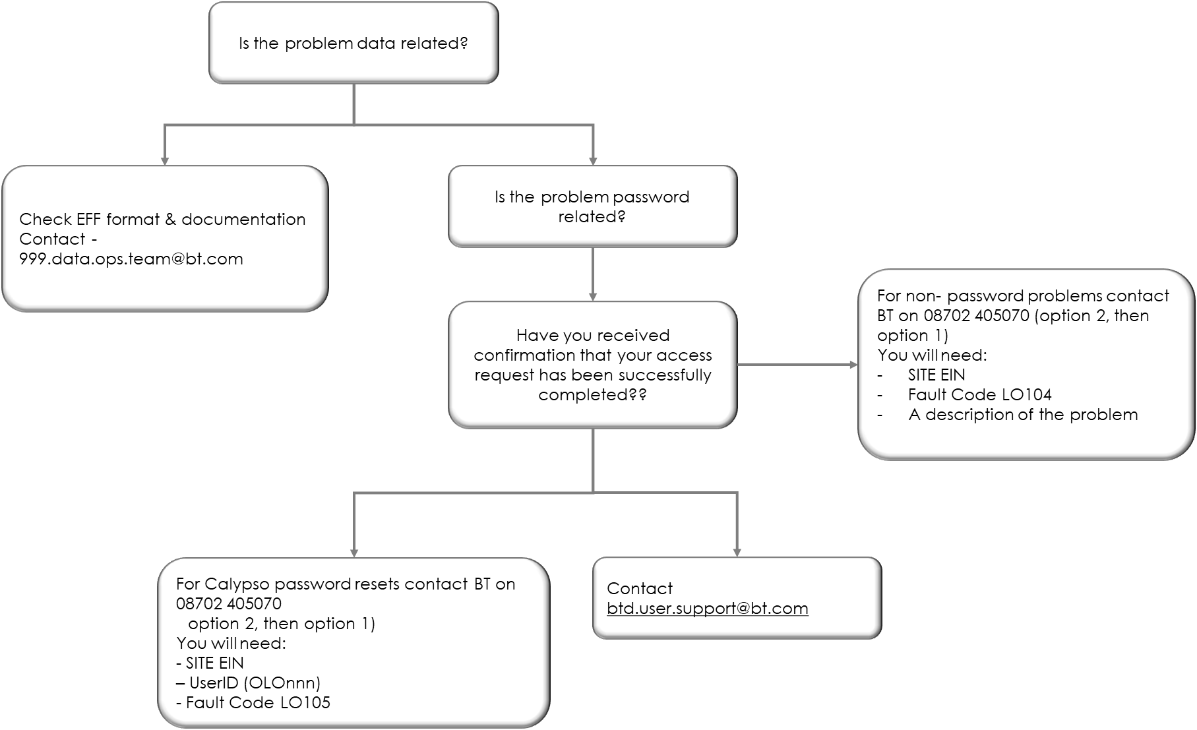

## 

## Glossary

|  |  |
| --- | --- |
| AUD | Audit File |
| CAR | Confirmation And Rejects |
| CIN | Corporate Information Network |
| CP | Communication Provider |
| CUPID | Communication Provider Identifier |
| DAT | Data file |
| EFF | Emergency File Format |
| FTPS | File Transfer Protocol |
| IP | Internet Protocol |
| PDG | Problem Diagnostics Guide |
|  |  |